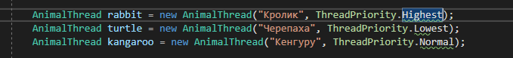

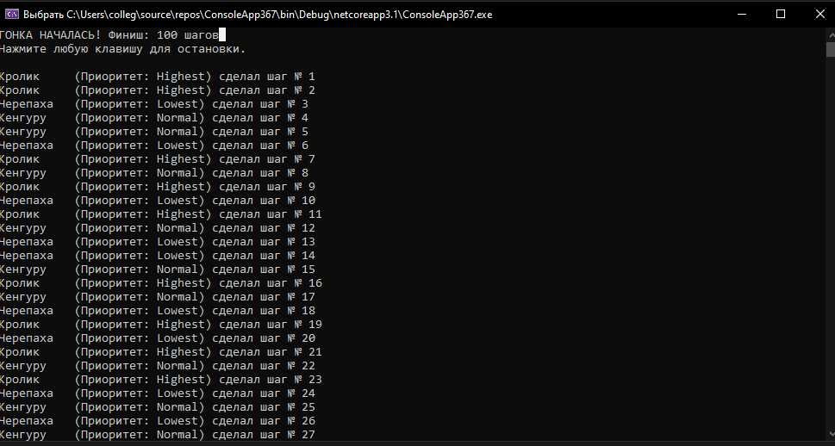
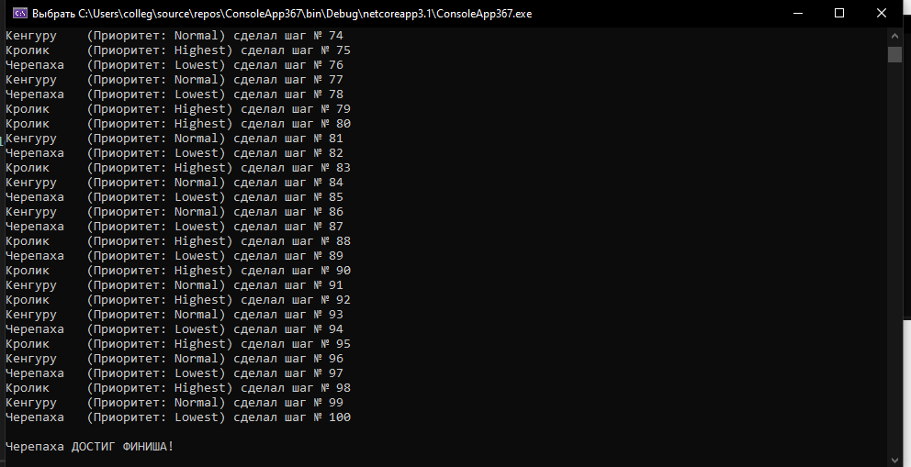
Меняем приоритет у зверушек
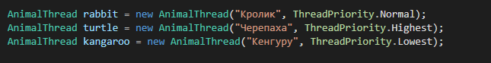
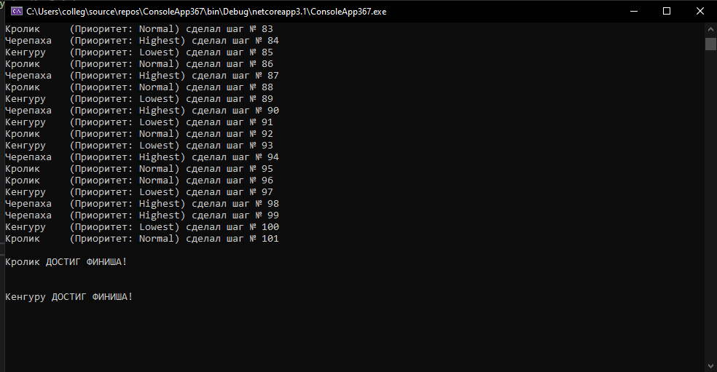

using System;
using System.Threading;

class Animal
{
public string Name;
public int Steps = 0;
public bool Finished = false;
public Thread Thread;
public Animal Opponent;

public Animal(string name, ThreadPriority priority)
{
Name = name;
Thread = new Thread(Run);
Thread.Priority = priority;
}

public void Start() => Thread.Start();

void Run()
{
while (!Finished)
{
if (Opponent?.Finished == true) break;

Steps++;
Console.WriteLine($"{Name} шаг {Steps}");

if (Steps >= 100)
{
Finished = true;
Console.WriteLine($"\n{Name} ФИНИШИРОВАЛ!\n");
break;
}

if (Opponent != null && Math.Abs(Steps - Opponent.Steps) > 5)
{
if (Steps < Opponent.Steps)
{
Thread.Priority = ThreadPriority.Highest;
Console.WriteLine($"{Name} отстает! Приоритет повышен");
}
else if(Steps>Opponent.Steps)
{
Thread.Priority = ThreadPriority.Lowest;
Console.WriteLine($"{Name} лидирует! Приоритет понижен");
}
else
{
Thread.Priority = ThreadPriority.Normal;
Console.WriteLine($"{Name} не отстает! Приоритет не изменен");
}
Thread.Sleep(50);
}
Thread.Sleep(10);
}
}
}

class Program
{
static void Main()
{
var rabbit = new Animal("Кролик", ThreadPriority.Normal);
var turtle = new Animal("Черепаха", ThreadPriority.Highest);
var Camel = new Animal("Жираф", ThreadPriority.Lowest);

rabbit.Opponent = turtle;
turtle.Opponent = rabbit;

rabbit.Start();
turtle.Start();
Camel.Start();

Console.ReadKey();

Console.WriteLine($"\n{rabbit.Name}: {(rabbit.Finished ? "Финиш" : rabbit.Steps + " шагов")}");
Console.WriteLine($"{turtle.Name}: {(turtle.Finished ? "Финиш" : turtle.Steps + " шагов")}");
Console.WriteLine($"{Camel.Name}: {(Camel.Finished ? "Финиш" : Camel.Steps + " шагов")}");
}
}

